**CRM APPLICATION FOR JEWEL MANAGEMENT- (DEVELOPER)**

**College Name:** St. Joseph’s College For Women

**College Code:** bru4i

**TEAM ID:**  NM2025TMID22089

**TEAM MEMBERS: 5**

**Team Leader Name:** Rani K.V

**Email:** shobikarani021@gmail.com

**Team Member 1:** Nandita.K

**Email:** n8105nandita@gmail.com

**Team Member 2:** Bhuvaneshwari.S

**Email:** bhuvanasindhu96@gmail.com

**Team Member 3:** Abiya.J

**Email:**[abiyakennadi@gmail.com](mailto:abiyakennadi@gmail.com)

**Team Member 4:** Kavyanandhini.R

**Email:**[kavyaaramesh001@gmail.com](mailto:kavyaaramesh001@gmail.com)

1. **INTRODUCTION**
   1. **Project Overview**

Build a Salesforce CRM app to help jewelry businesses manage customers, sales, and inventory. It tracks leads, orders, and stock, while sending reminders and supporting marketing campaigns. The app improves customer service, boosts sales, and organizes operations. Built using Salesforce Sales Cloud with custom features. The goal is to simplify jewelry business management in one platform.

* 1. **Purpose**

The purpose of the CRM application for jewel management in Salesforce is to centralize and streamline customer and sales data for jewelry businesses. It helps track customer interactions, manage leads, and monitor inventory efficiently. The system automates follow-ups and personalized marketing to enhance customer engagement. It ensures accurate order and sales processing, reducing errors. Real-time reporting supports better decision-making. Overall, it improves operational efficiency and boosts sales growth.

**DEVELOPMENT PHASE**

Creating Developer Account:

By using this URL- https://www.salesforce.com/form/developer-signup/?d=pb

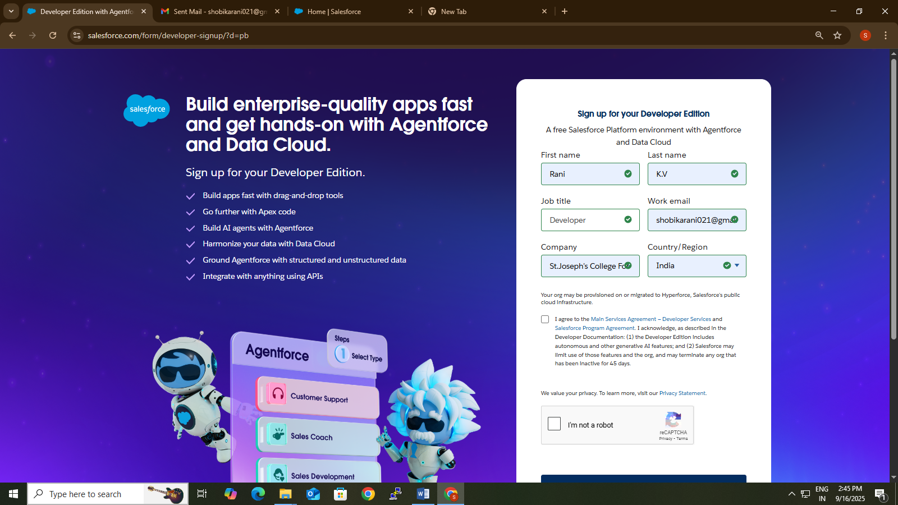

* **Created Objects: JewelCustomer,Item,CustomerOrder,Price,Billing**

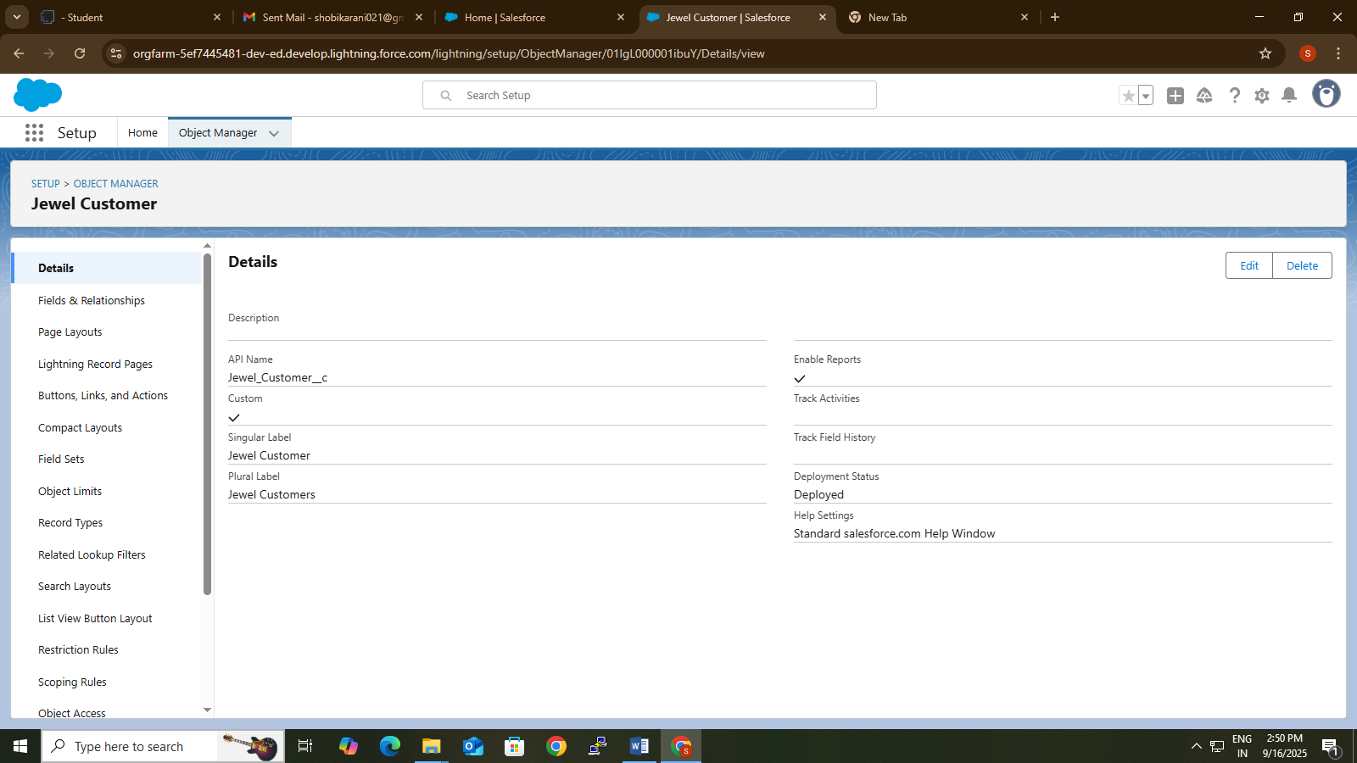

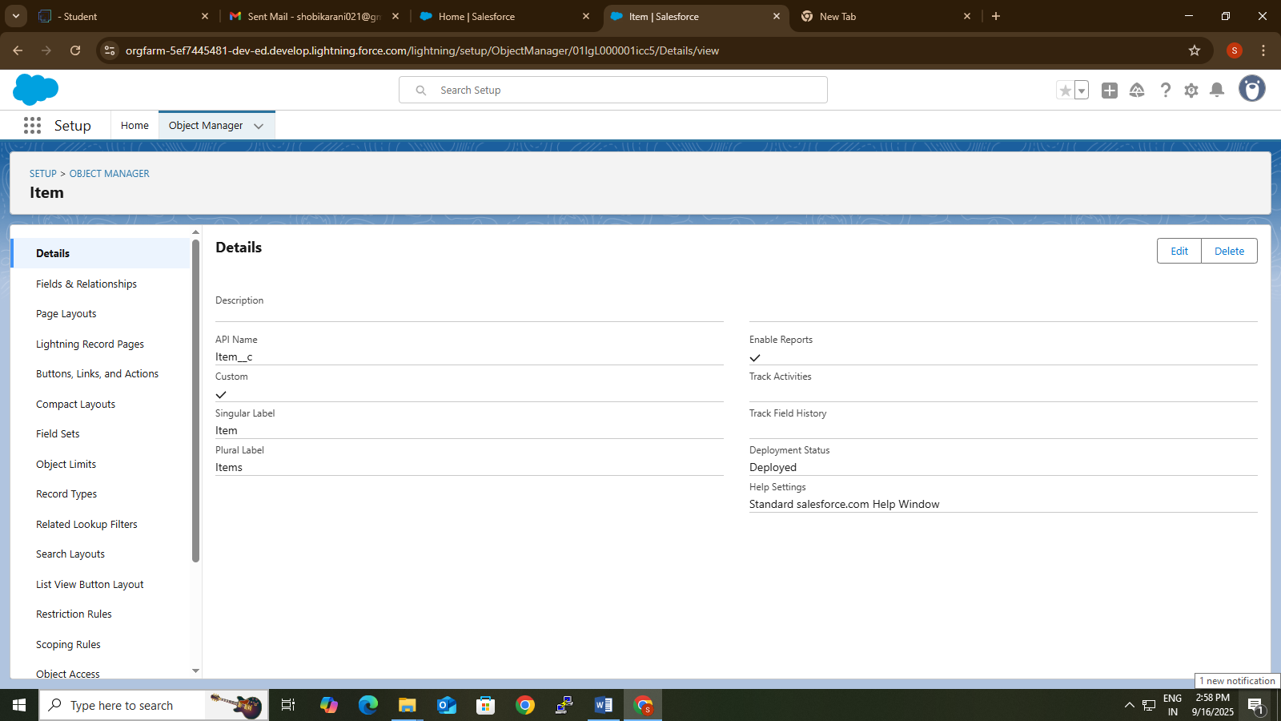

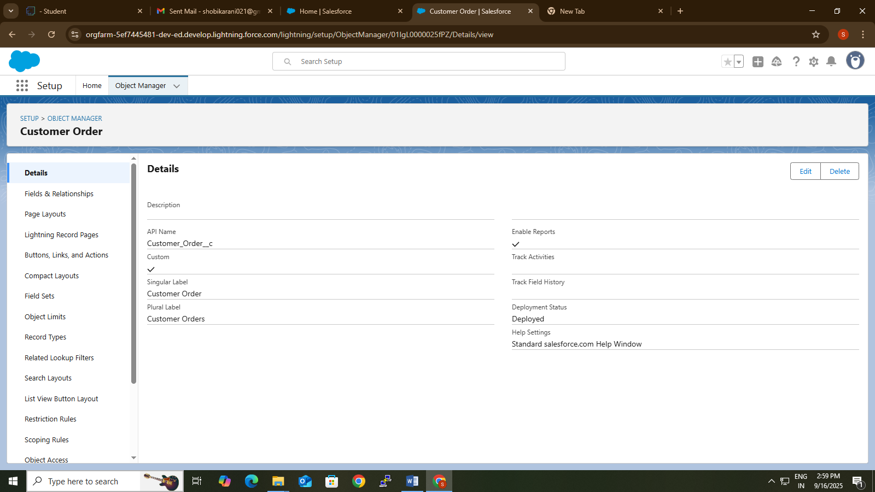

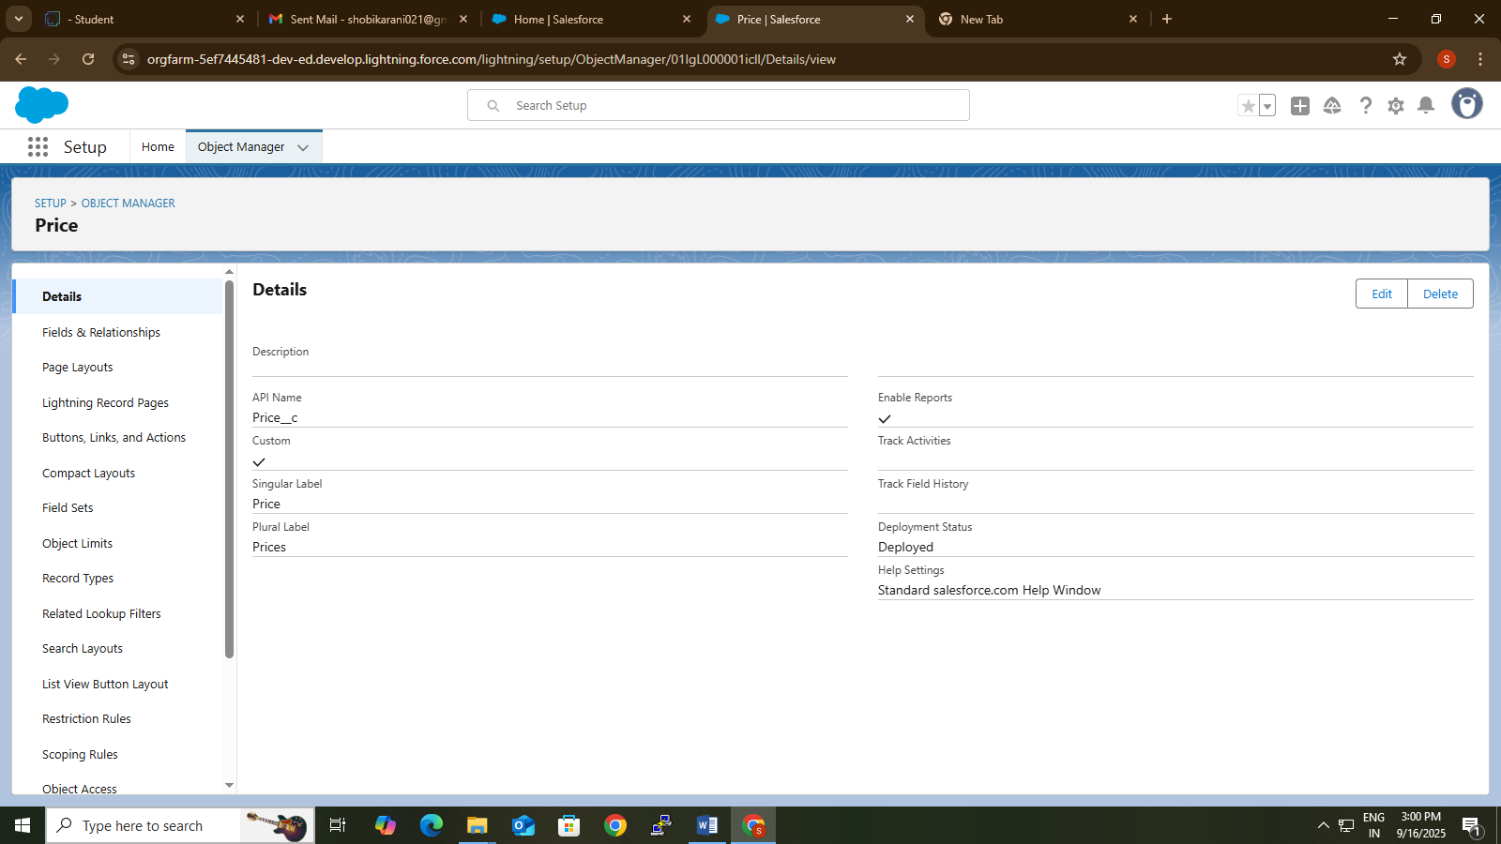

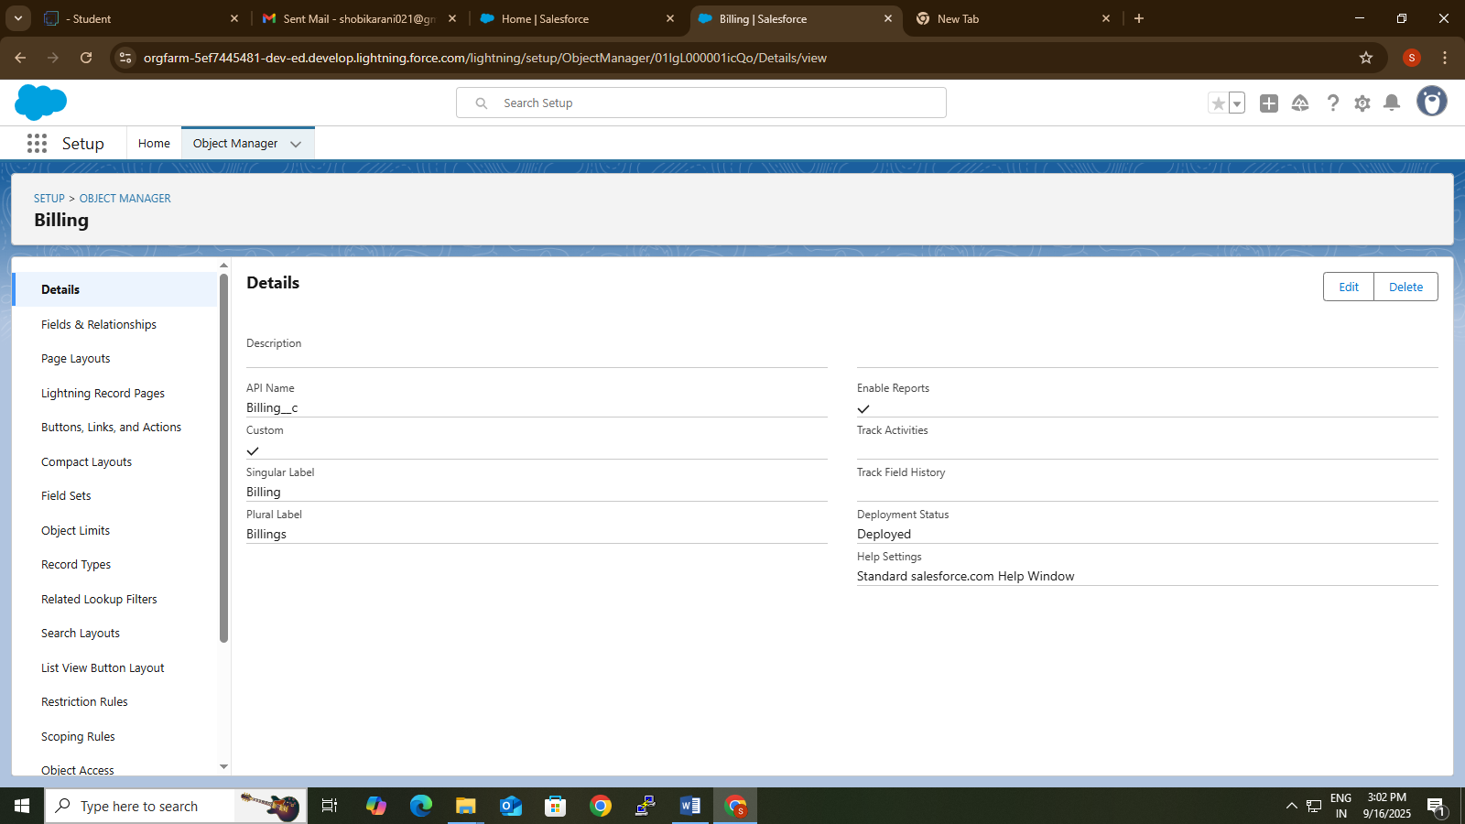

* **Developed Lightning App With Relavent Tabs**

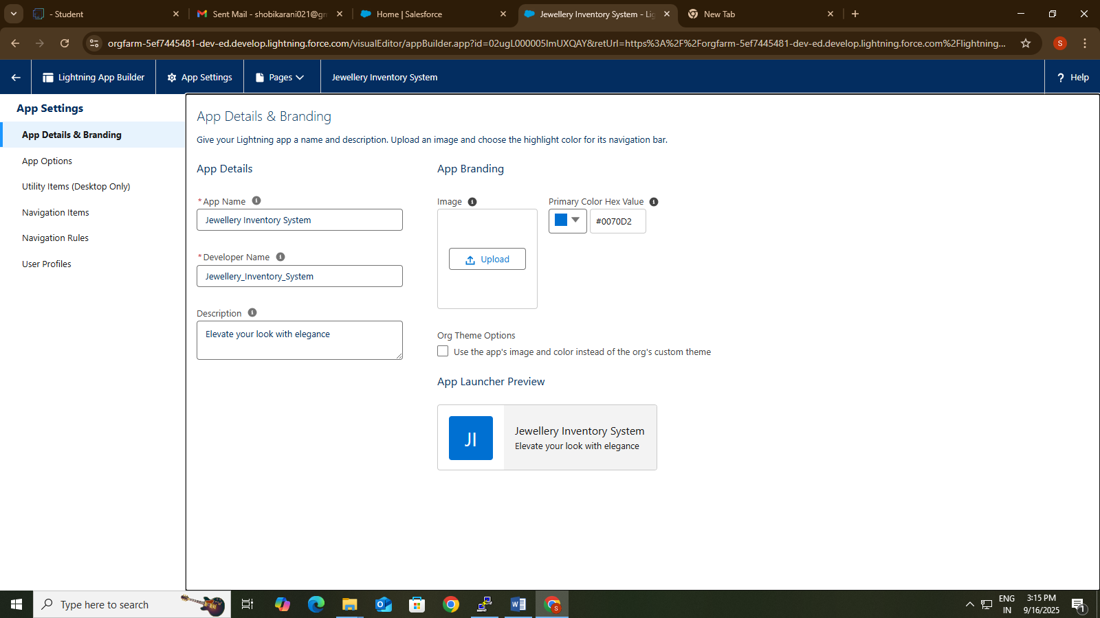

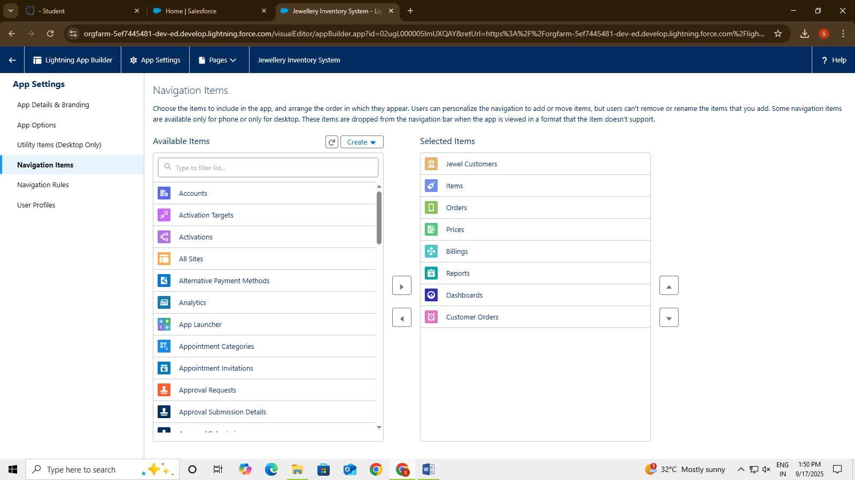

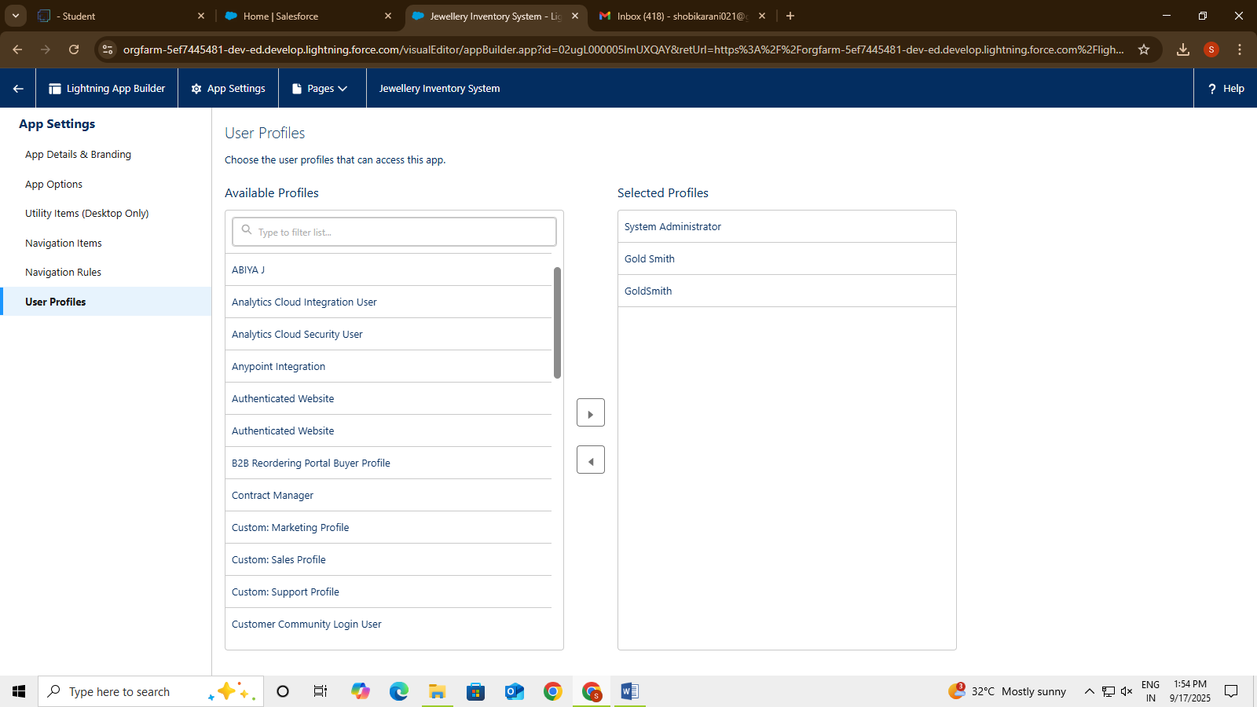

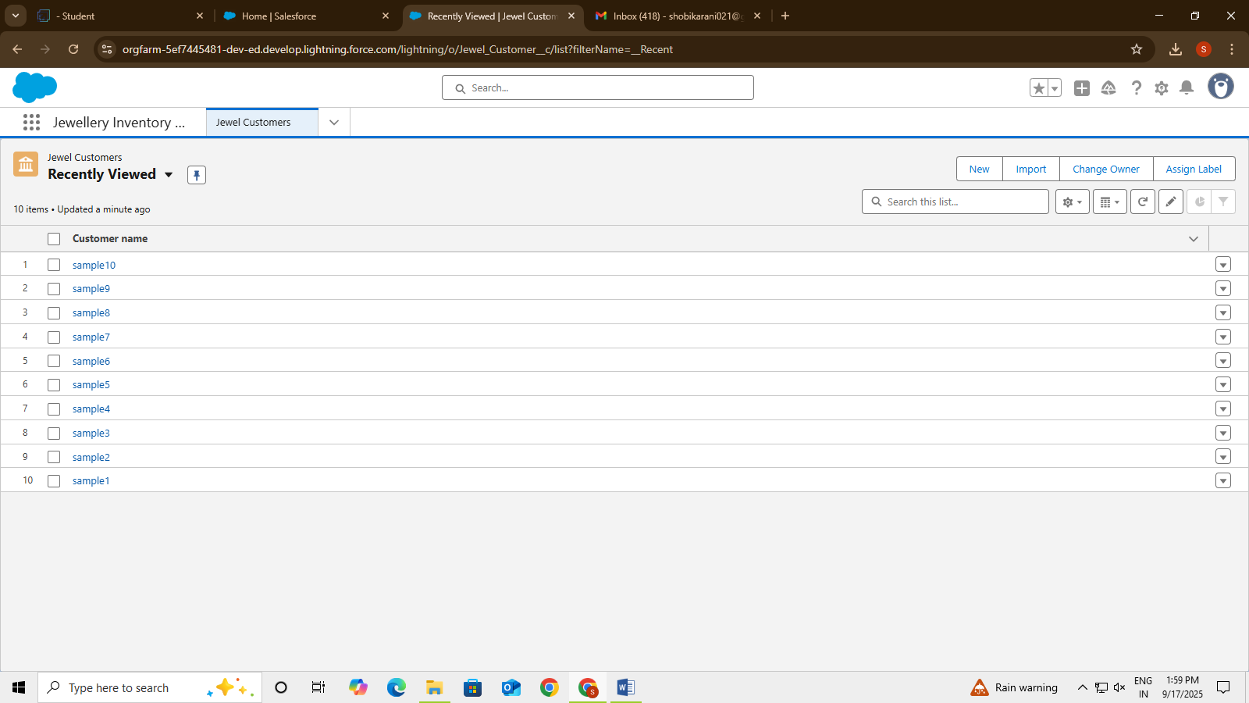

* **Configured fields and relationships**

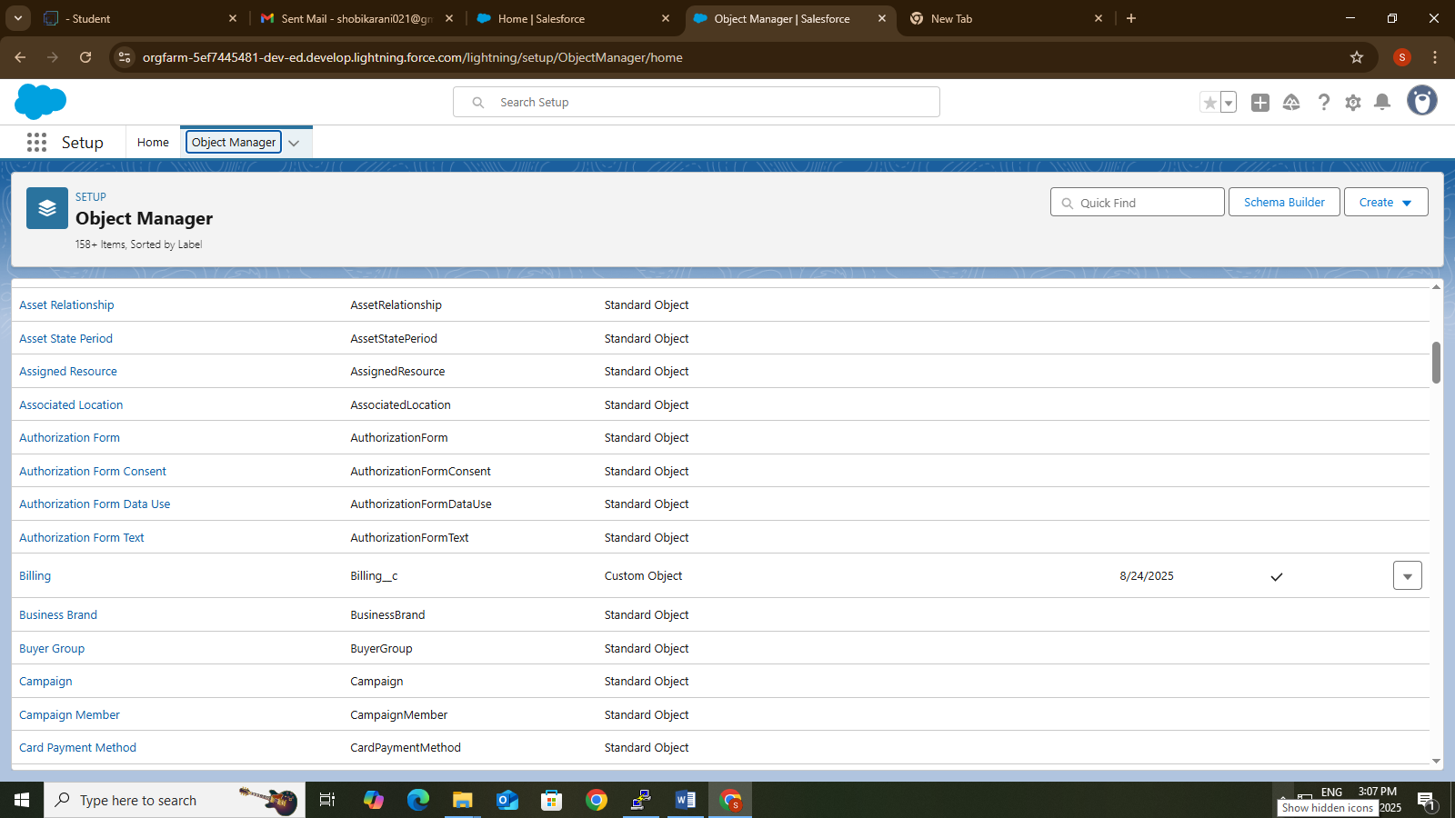

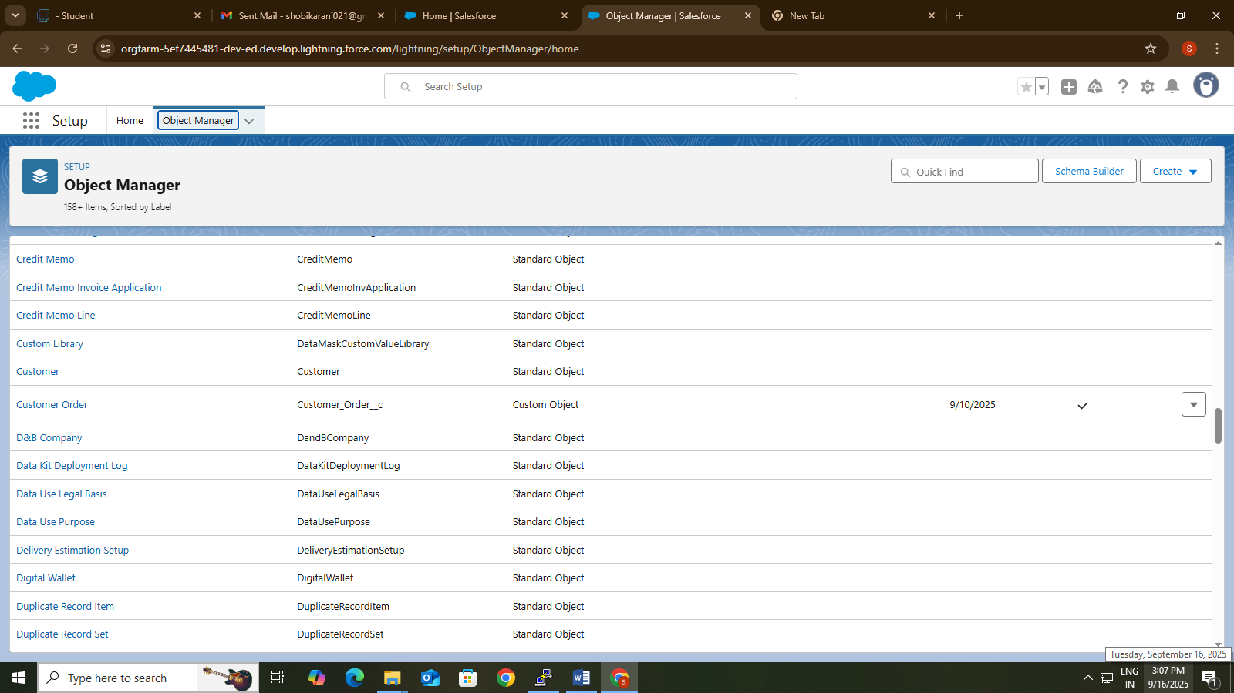

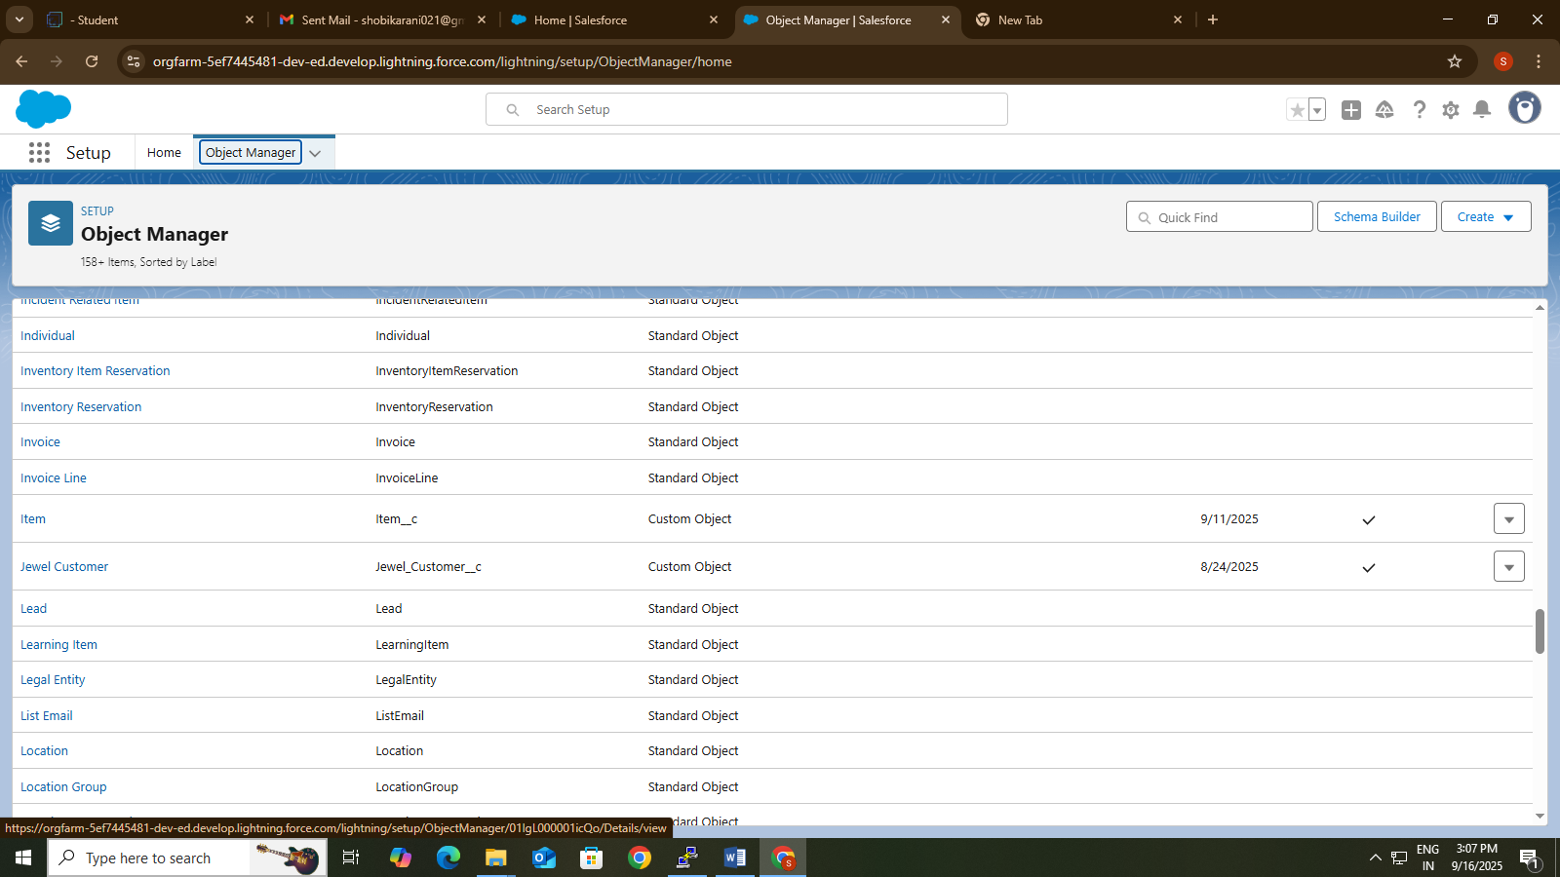

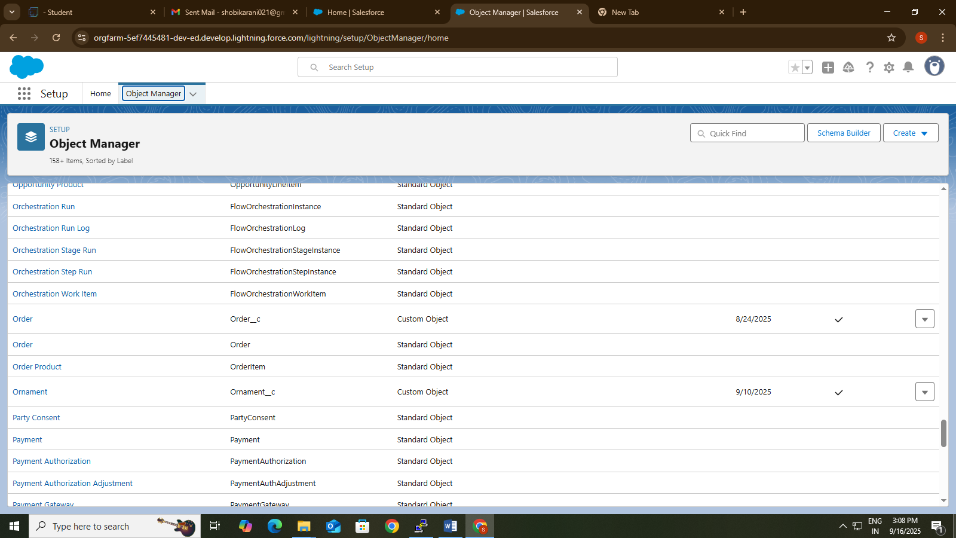

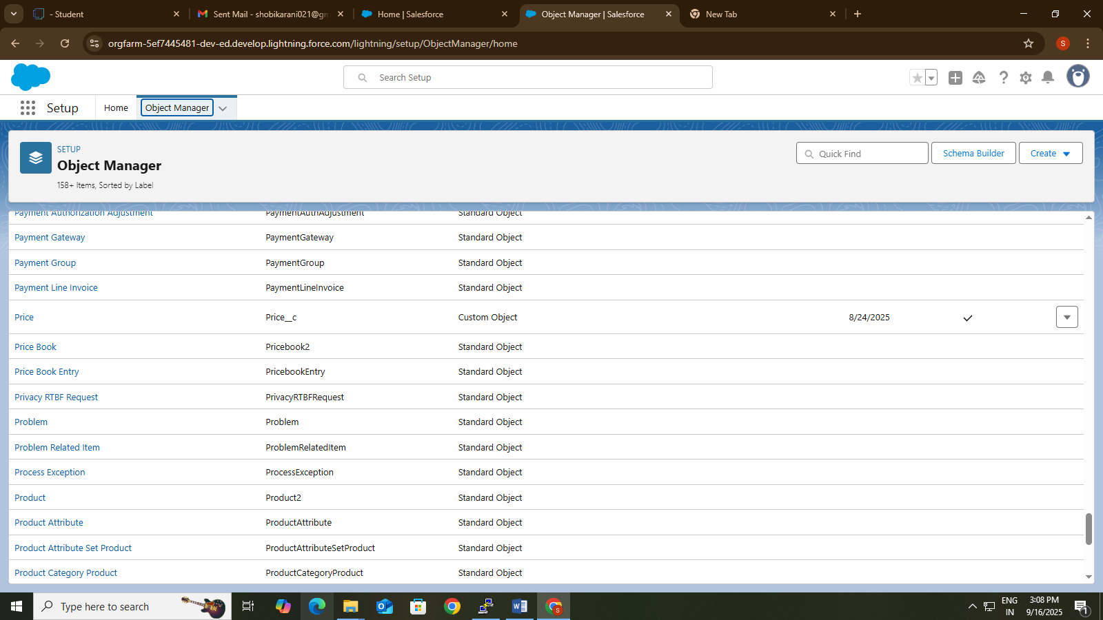

* **To create a validation rule to a Jewel customer Object**

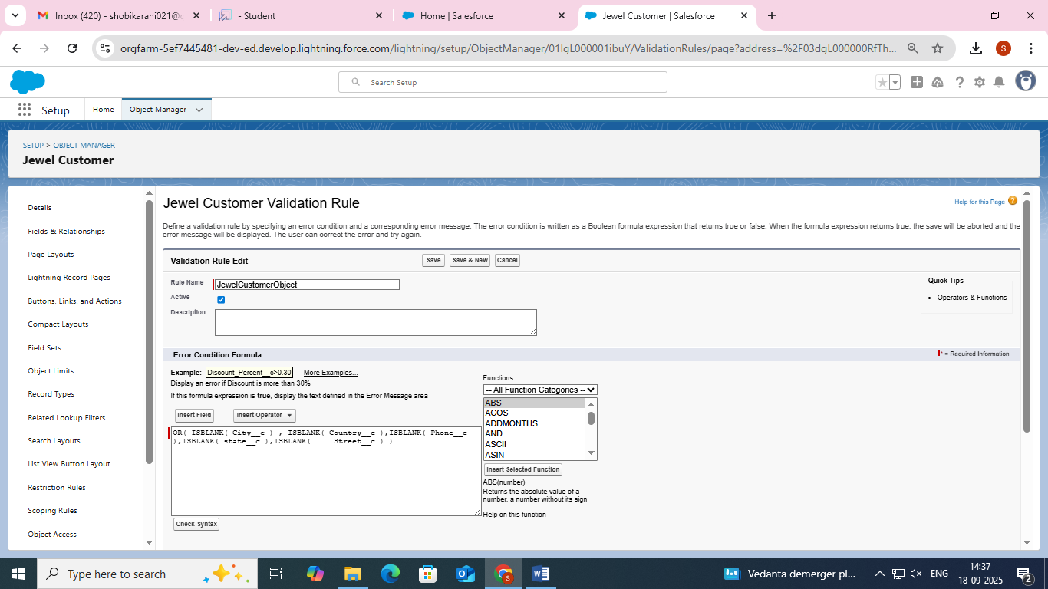

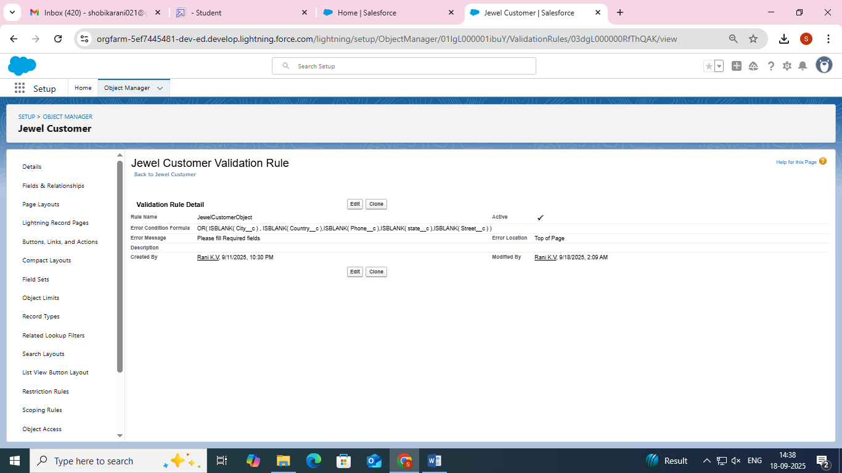

* **Creating a Trigger**

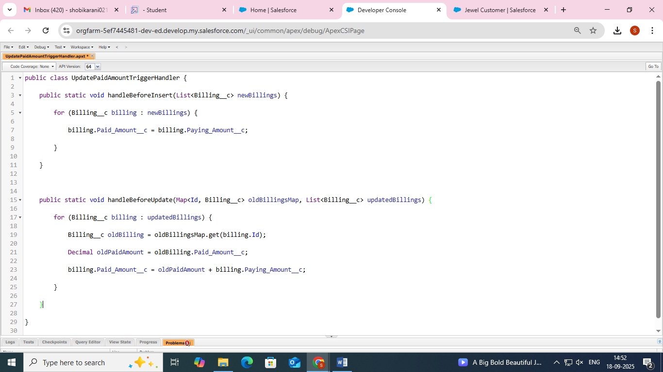

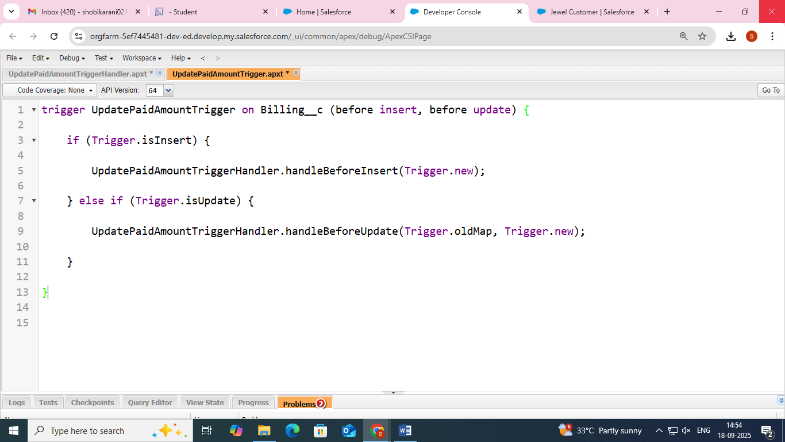

* **Creating Profiles**

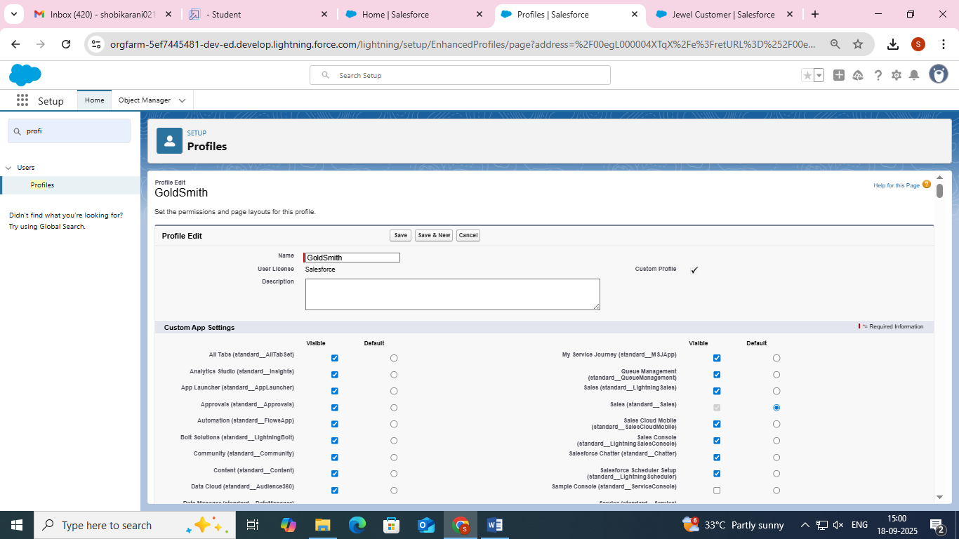

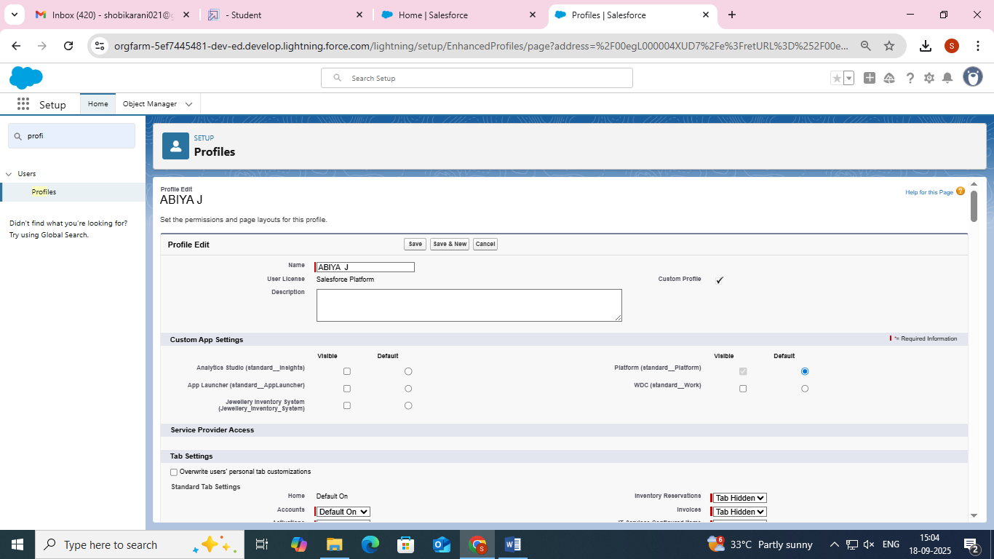

* **Creating Roles**

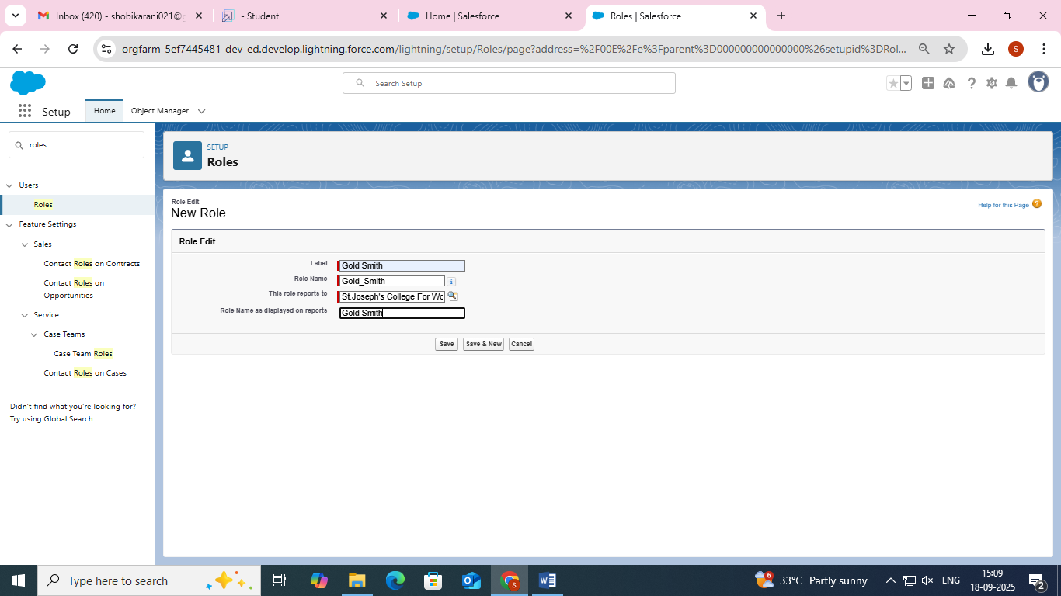

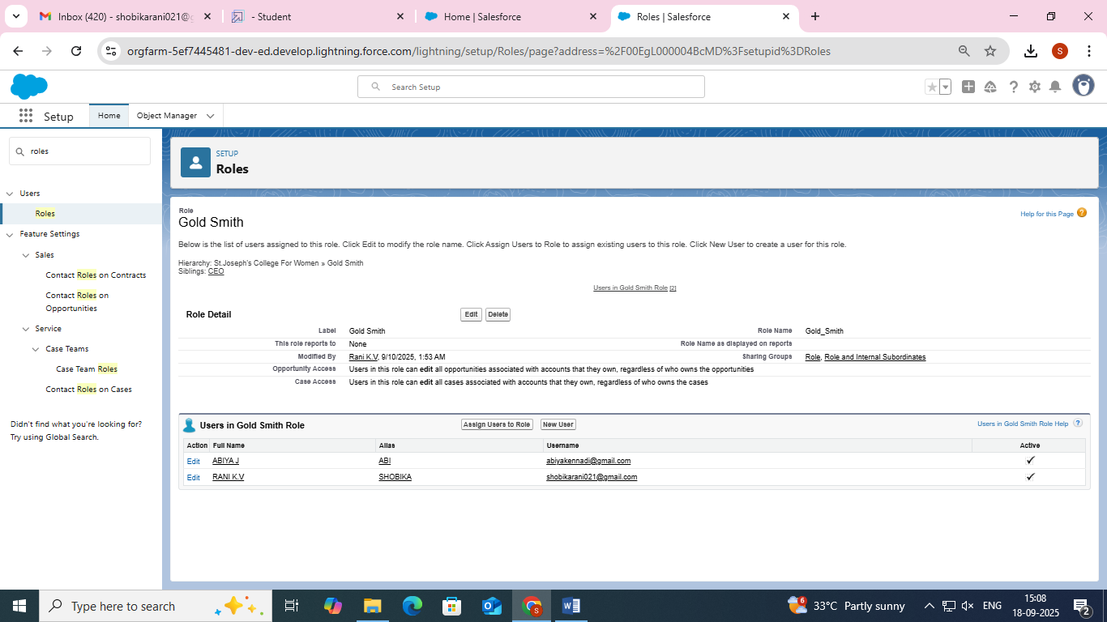

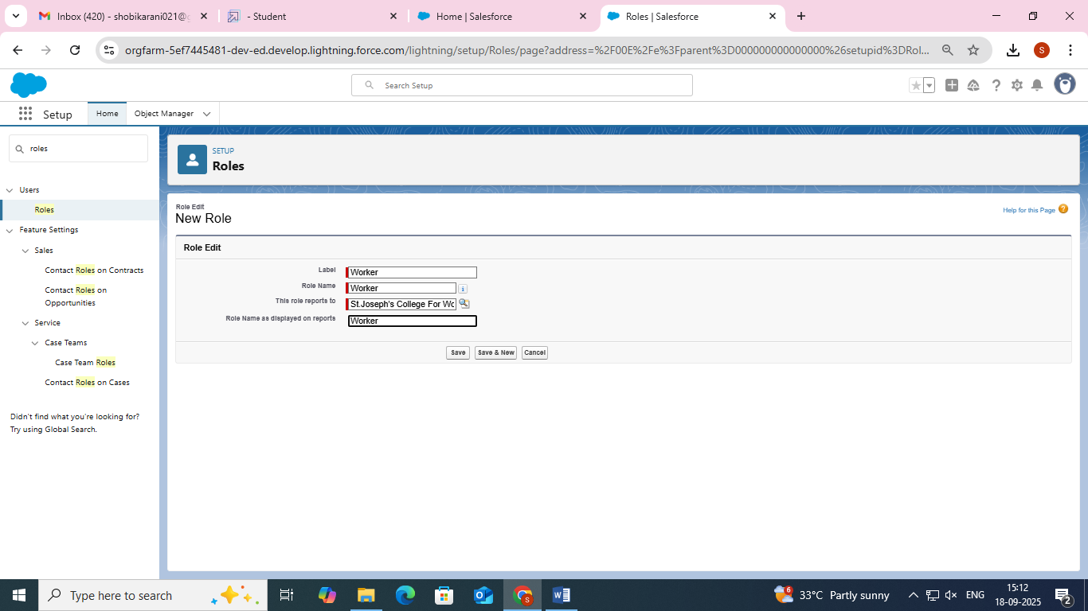

* **Creating Users**

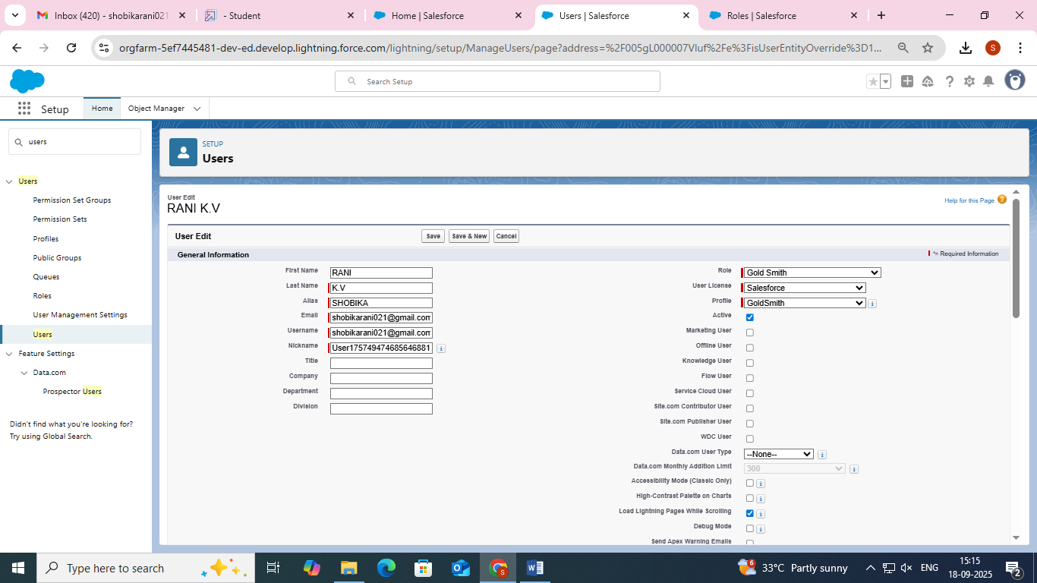

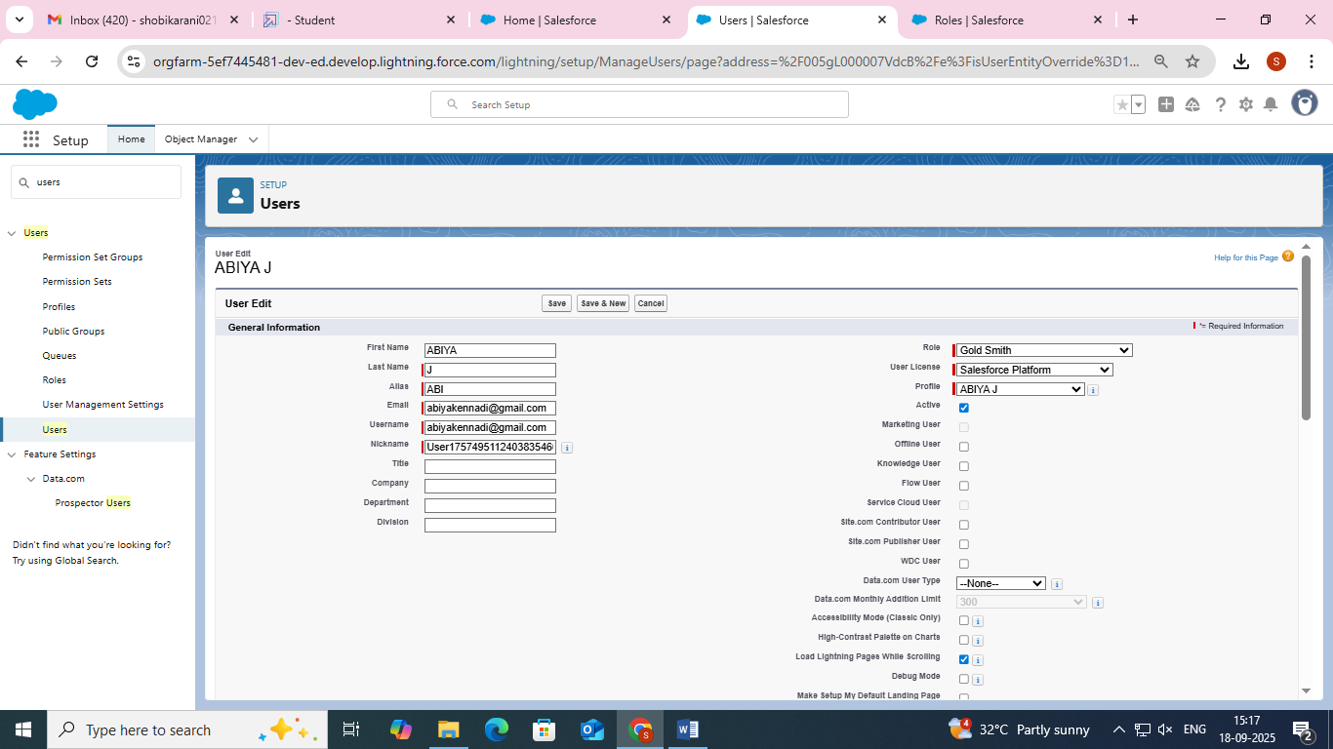

* **Creating Page Layout**

**Gold**

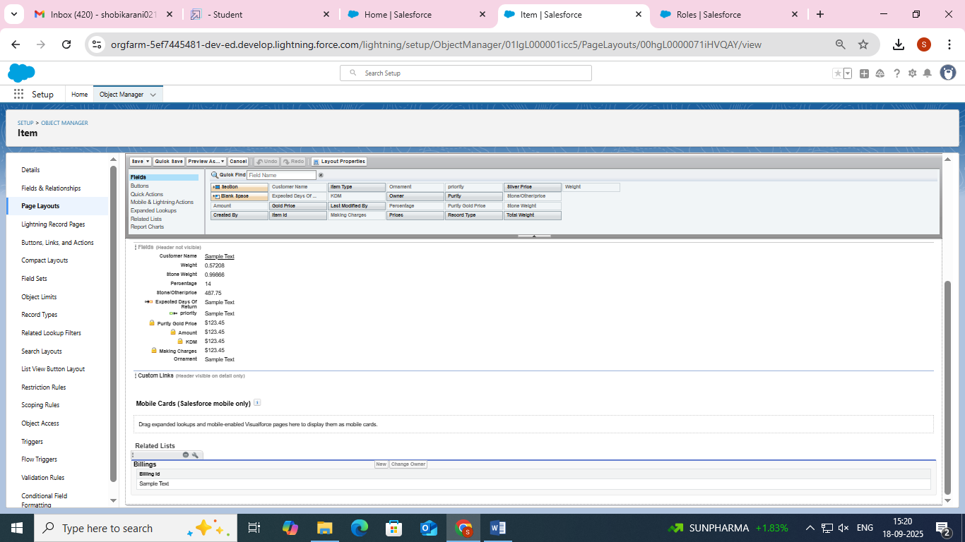

**Silver**

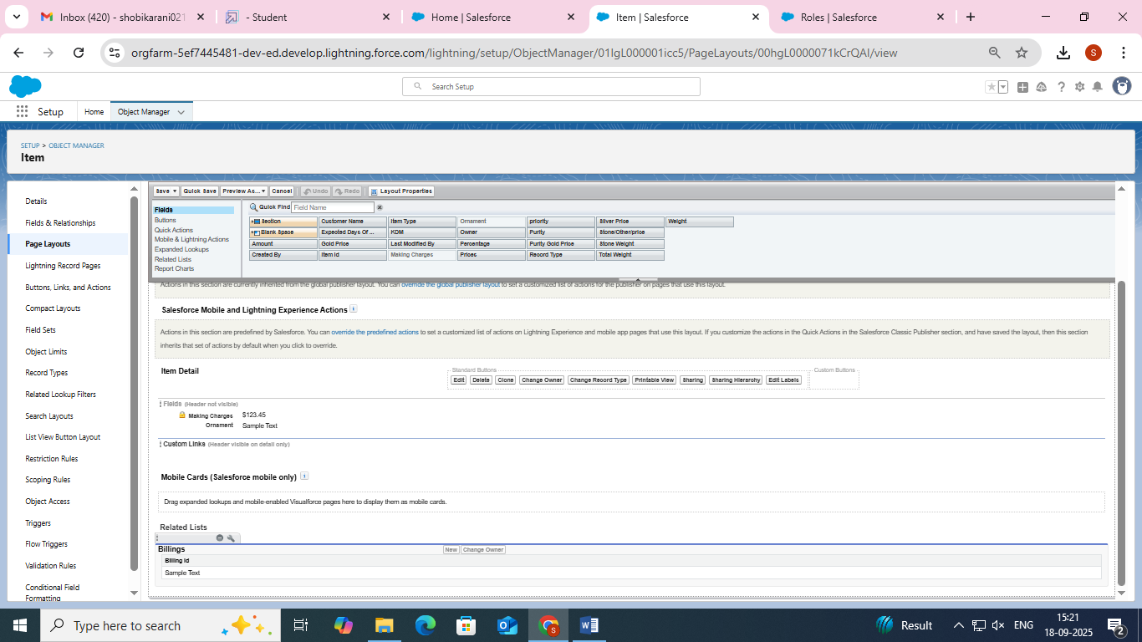

* **Creating Record Type**

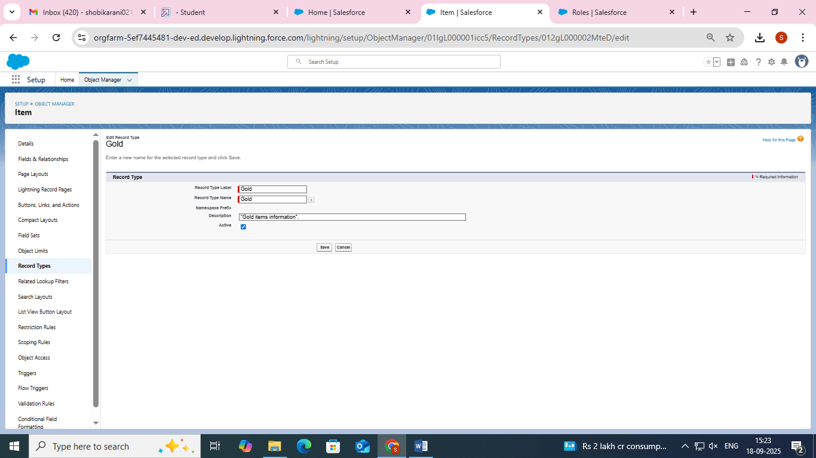

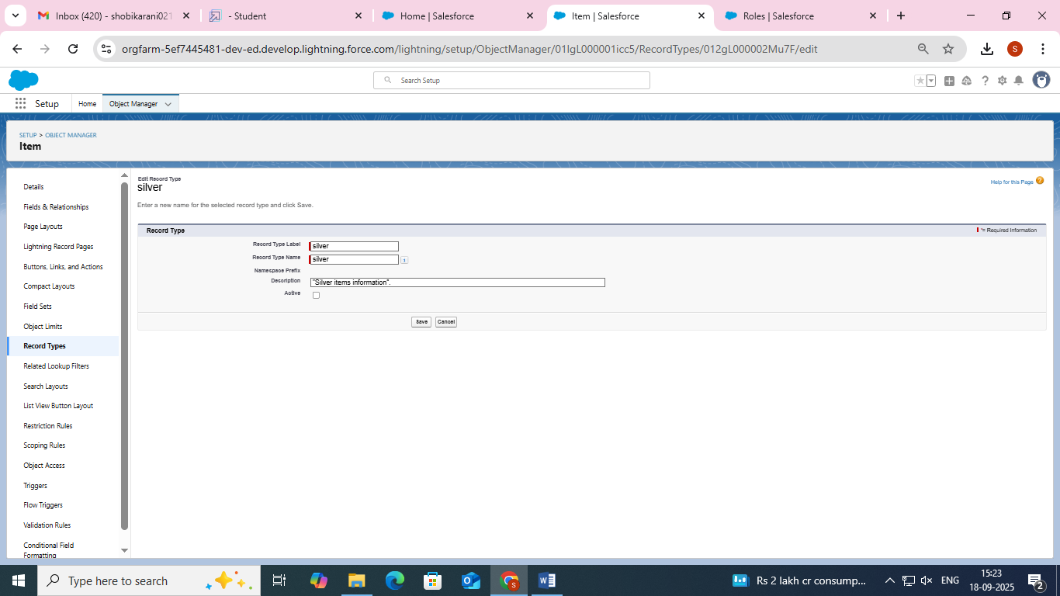

* **Creating Permission Set**

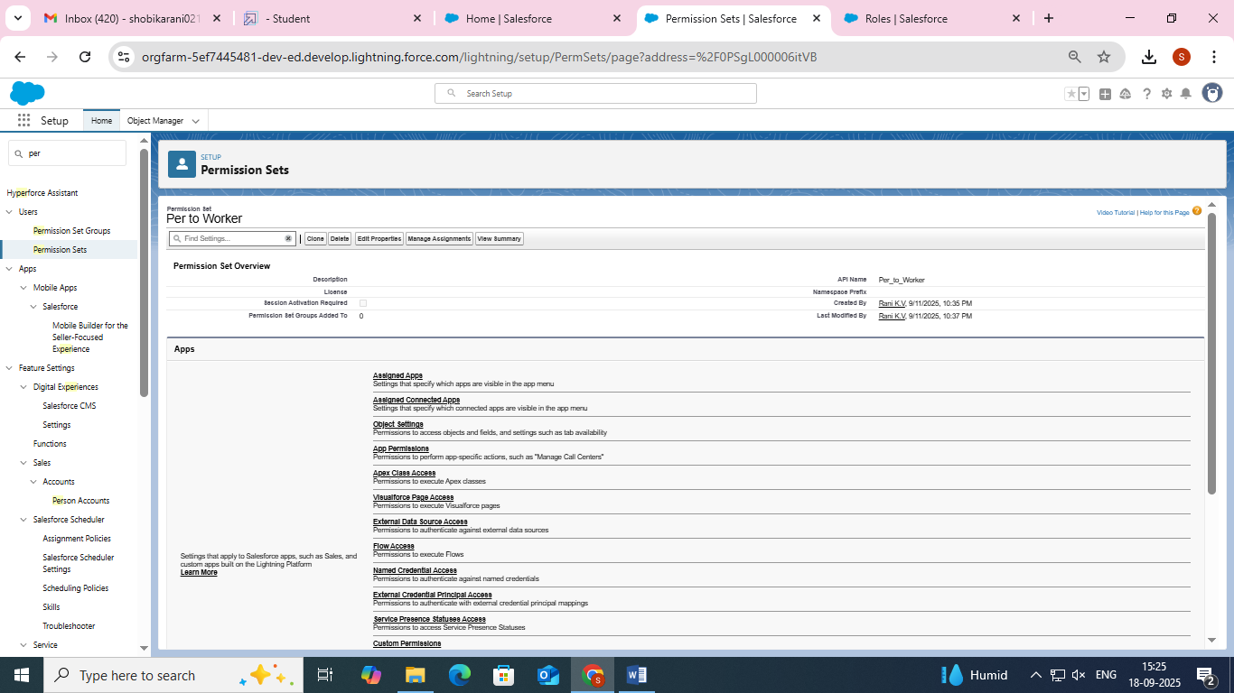

* **User Adoption**

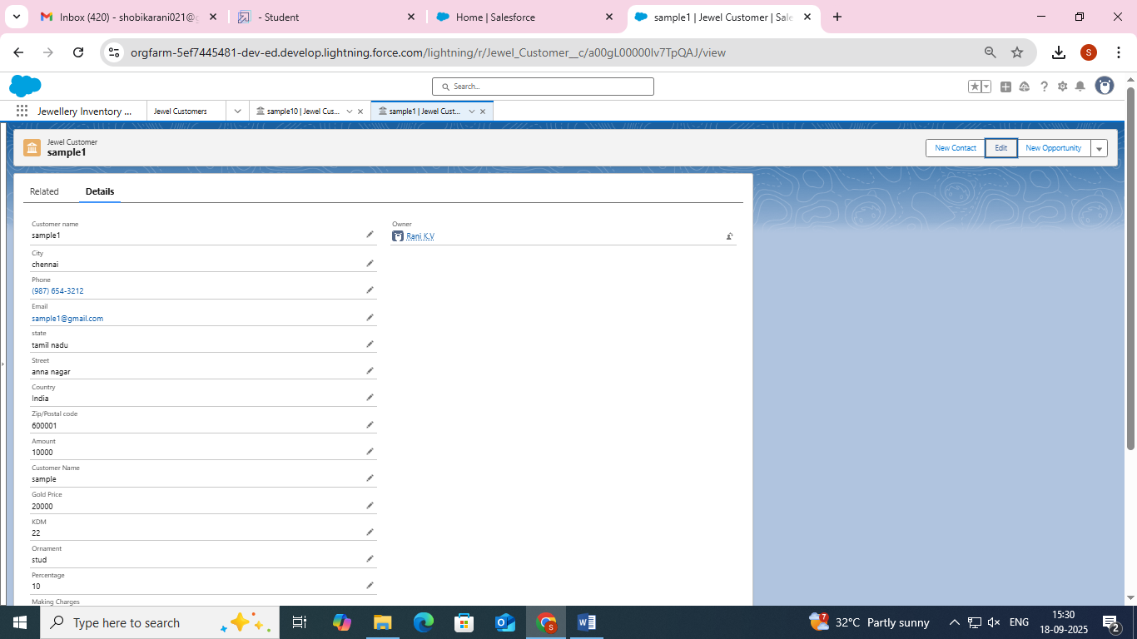

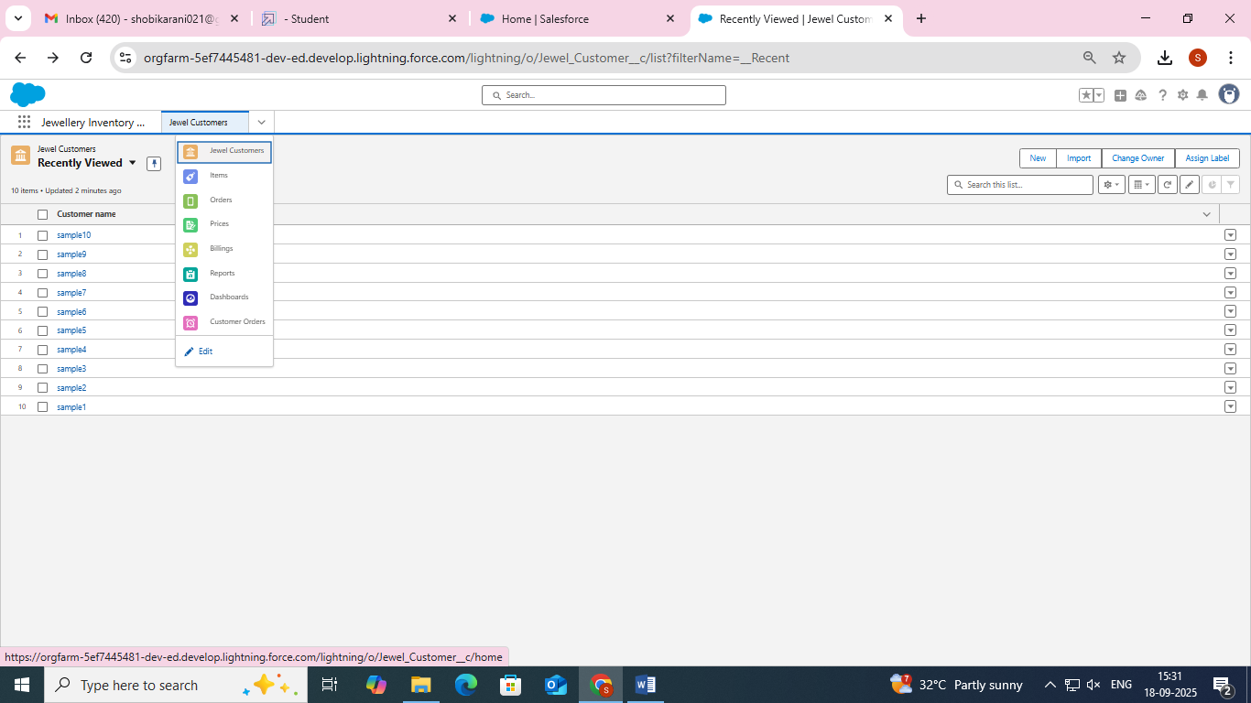

* **Reports**

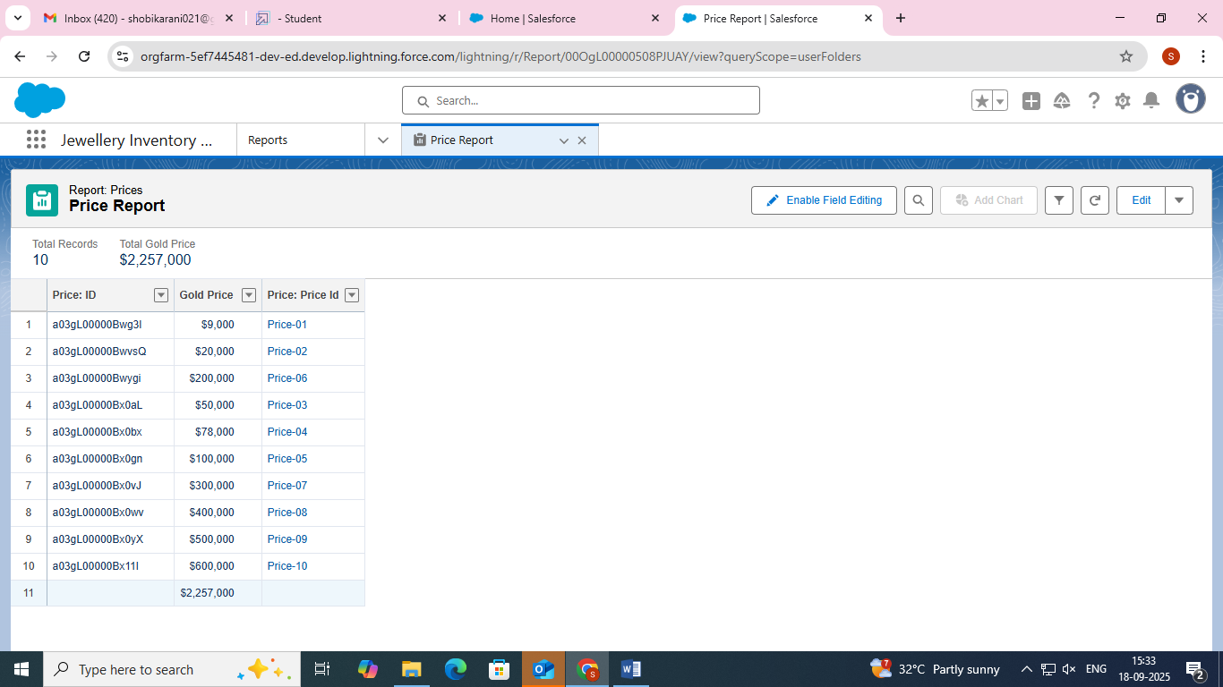

* **Creating Dashboard**

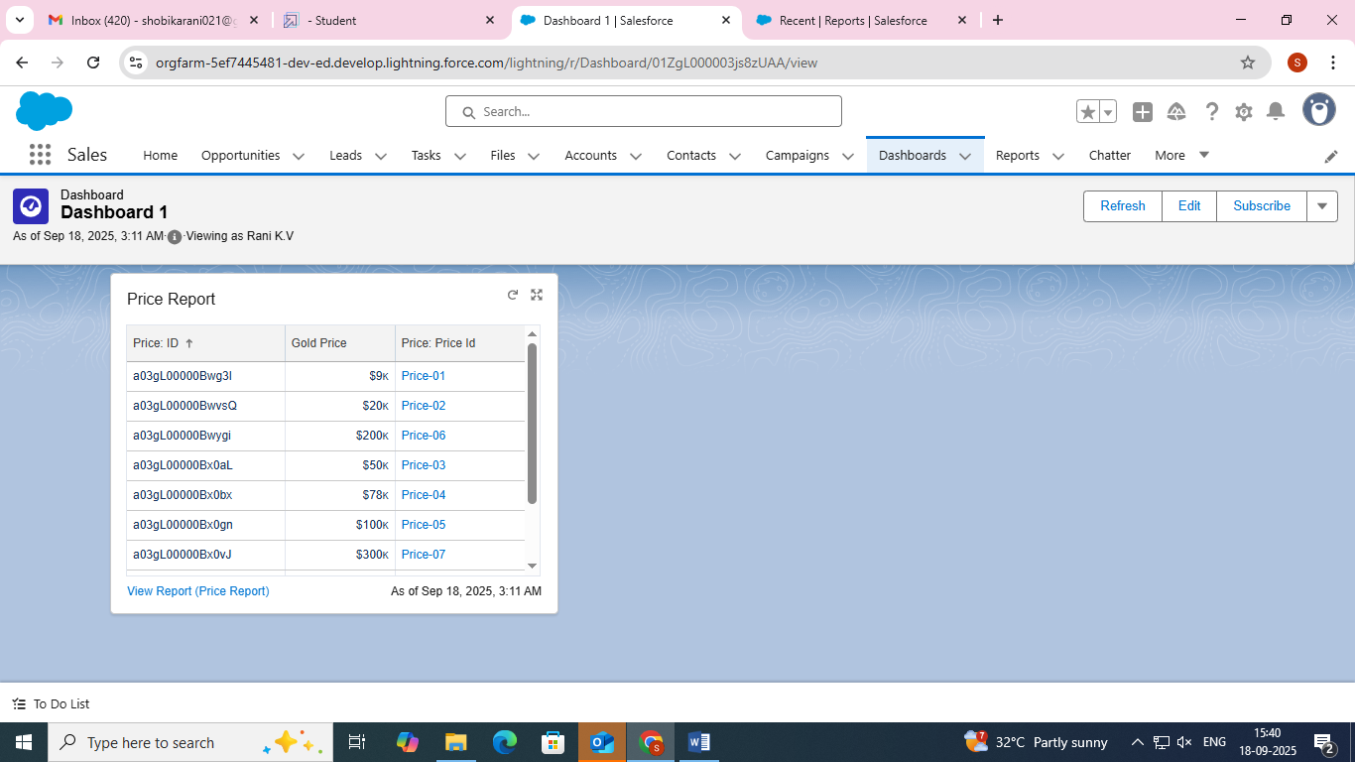

* **Flows**

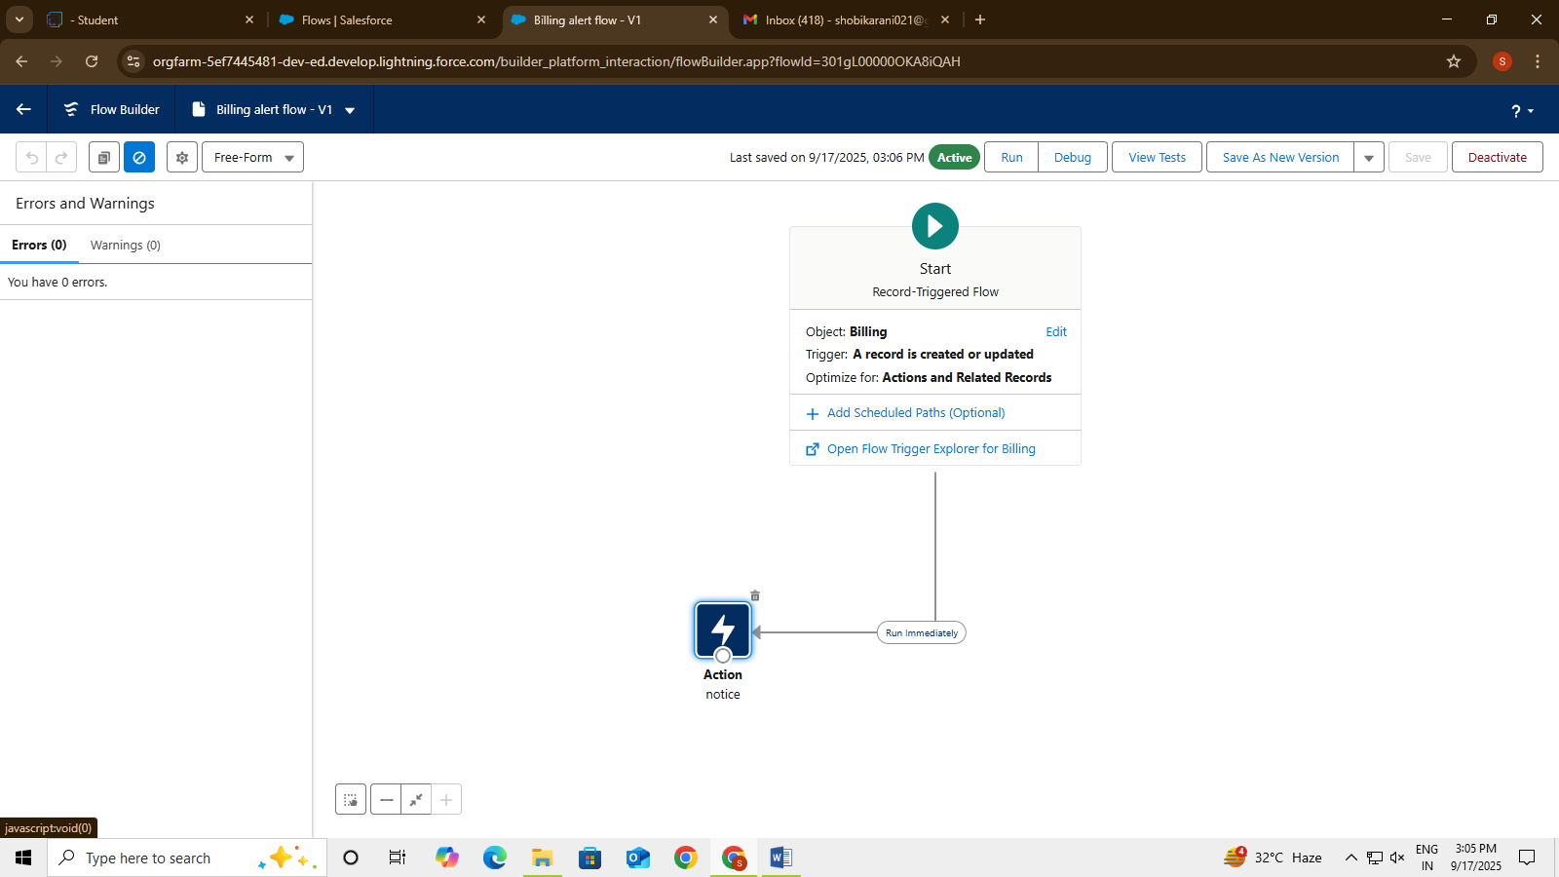

**CONCLUSION**

In conclusion, implementing a CRM application for jewel management within Salesforce offers a streamlined, efficient, and scalable solution for managing sales, customer relationships, and inventory in the jewelry industry. By leveraging Salesforce's powerful features like automation, data analytics, and seamless integration with other tools, the application significantly enhances the ability to track customer interactions, optimize sales processes, and manage stock levels in real-time.